50 BEST HOLIDAYS IN SPAIN The Times

The best painting, stargazing and motorsport in Spain in 2018

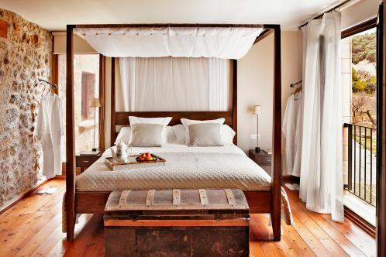
Mas de la Serra is launching painting holidays this year
Painting in Matarranya
The dreamy Hotel Mas de la Serra in Matarranya (often nicknamed Spain’s Tuscany) is launching painting holidays for 2018. In June the English artist Julia Cassels will lead the group, while in October the Scottish fine artist Penelope Anstice will be the tutor. Locations will vary, but are almost certain to include the hotel’s almond-tree grove, where ibex can often be seen. The hotel is in 60 acres of grounds, meaning plenty of short walks are available.
Details From £1,995pp for seven nights’ full board, including flights (020 7359 3938, realholidays.co.uk)

